**Salmon River Rafting Site Plan**

**Sherri Walter**

**Overview**

Purpose

The purpose of this site is to market the Salmon River Whitewater Rafting company. It will do so by providing detailed information such as pricing, and what to expect on your adventure. Each adventure will be described in detail including state of the art equipment, location and what to expect. It will also provide information about the experience of the staff in taking out groups for rafting. Staff members will have bios so customers will feel comfortable and safe.

Audience

The ideal customer for Salmon River are athletic families, individuals and groups looking for an outdoor adventure that will bring them closer to nature and each other. It is ideal for clubs, teams, business groups, families and individuals. Customer looking for a growth experience and enjoy being challenged will want experienced guides and safe equipment.

Persona 1 – John Porter

John is a 30 year old project manager for an identity managment team that works at different locations and time zones. He is looking for a corporate retreat for his team to create unity. He is looking for an activity that will push team members out of their comfort zone and create a bond. His team does not do much outdoors, so he wants to make sure he chooses an adventure that is not beyond anyone’s skill level.

Persona 2 – Lilianne Coury

Lilianne is 38, a stay at home mom is in charge of her family reunion this year. She is looking for an activity that will be exciting and appeal to a variety of ages. One of the things she is looking for is a photo opportunity. She loves sharing photos online and wants an adventure that has professional photography available to capture the moment. She wants something that is affordable, but not so affordable that it is not memorable.

**Branding**

Website Logo

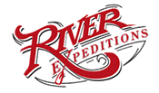

**Style Guide**

Color Palette



Typography

Header Font: Playfair Display

This font conveys movement and excitement. Limitless Discovery will overlay a picture of the rapids.

Heading Font: **Montserrat Bold**

This font is clean and easy to read. It commands attention without stealing the show.

Paragraph Font: Montserrat Regular

Paragraphs will be in Montserrat regular for a clean uniform look.

Site Map

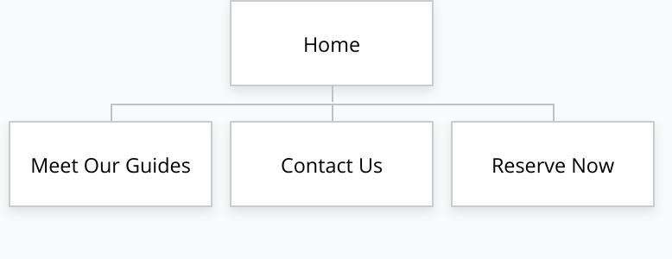

Wire Frames